22nd February 2018

**YOKOHAMA to Exhibit at FC EXPO 2018 – 14th International Hydrogen & Fuel Cell Expo**

YOKOHAMA will be an exhibitor at FC EXPO 2018 – 14th International Hydrogen & Fuel Cell Expo, to be held at the Tokyo Big Site (in Tokyo’s Koto Ward) from 28th February to 2nd March. YOKOHAMA is participating in this event for the first time, and its booth will introduce visitors to the Company’s "ibar" series of high-pressure hydrogen gas hoses.   
  
The "ibar" hoses were developed in cooperation with Iwatani Industrial Gases Corporation as hydrogen dispenser hoses to be used for filling fuel cell vehicles (FCVs) with hydrogen fuel. FCVs are expected to come into widespread use in the future. The "ibar" series now includes three hoses – the "ibar HG35" compatible with a dispensing pressure of 35MPa, the "ibar HG70" for use at 70MPa, and the "ibar HG82" for use at 82MPa. In addition to the hoses use with FCVs, the exhibit booth will appeal to their suitability for transporting compressed hydrogen in hydrogen production plants, another application where the hoses have demonstrated excellent performance. At present, metal pipings are used when transferring compressed hydrogen to a curdle* or other container, but "ibar" hoses are lighter and more flexible, making them easier to transport and use in filling operations. The rubber hoses also are more durable and safer.  
  
FC EXPO 2018 is an exhibition promoting international business consultations and exchanges of information and introducing the latest developments in hydrogen and fuel cell R&D, as well as all the technologies, parts and materials, equipment and fuel cell systems. Visitors include makers of fuel cells, electronics companies, automakers, energy companies, and construction and plant engineering firms, as well as university R&D centers and local governments.  
  
*Curdles are containers that hold several gas cylinders, making it possible to safely transport a larger volume of compressed gas on a single truck trailer.

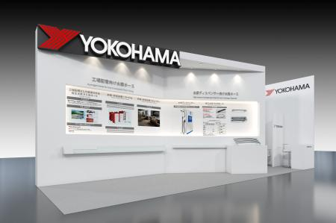

*Image of the YOKOHAMA booth at FC EXPO 2018*